Fort Edmonton Foundation 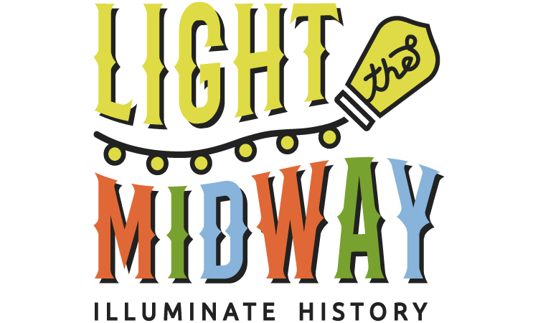
Meeting Agenda
Tuesday, November 17, 2020 5:30-7:30 pm
Join by Zoom https://us02web.zoom.us/j/9706632670 Passcode: 1038
Attending Board Members: Jason Clarke, President, Michael Paull, Past President, Paul Harris Treasurer, Andrew Otway, Vice President, Grace Kallal, Tim Marriott, Jim Wachowich, Josh Ramsbottom,Stephen Lau, Clayton Tiedemann, Michael Lohner, Angela Ferguson, Ryan Young, Alle DeMelo
Guest: Darren Dalgleish, CEO of FEMCo

Staff: Janet Tryhuba, Executive Director, Anne Brown, Executive Administrator

Land Acknowledgement:
At this time, we acknowledge that we are on the traditional land of Treaty Six Territory and the Traditional Métis Homeland of Region IV (four). We acknowledge the diverse Indigenous Peoples, whose ancestors’ footsteps have marked this territory for centuries; from First Nations, Métis, Inuit, and now settlers from around the world.

We do this to create awareness that we are all treaty members, and to show recognition and respect for Indigenous Peoples and the traditional territories on which we live and work.

- Call to Order
- Approval of the Agenda
- Presentation: Darren Dalgleish - Update on Enhancement Projects
- Approval of Minutes October Meeting
Reports:
- Operational Oversight - Jason
  - Update on FEMCo/FEF/COE MOU Discussions
- Finance - Paul
- Capital Campaign/Chief Factor’s Breakfast- Clayton
- Light The Midway - Michael/Ryan
- Governance - Andrew
- External Community and Government Relations - Tim
  - Glow Gardens Coat Check December 26/27 - Josh/Anne
- Fall For The Fort Auction - Grace
  - Donor Thank You calls
- Executive Director’s Report - Janet
- Recommendation for following motion, to approve application for eligibility to AGLC for raffle licence over $20,000

Adjournment

In Camera Session - as needed

