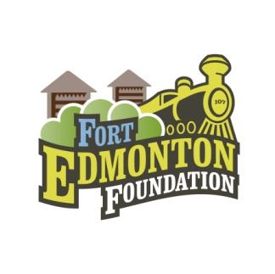
Fort Edmonton Foundation
Report for FEMCo Board
April 2021

Dashboard Report of Current Campaign Strategies (as of April 15 2021):

Campaign Progress | YTD # of donors/sponsors | YTD Average gift | Actual YTD Total Raised
Total Donations & Capital Campaign | 1 New $30,000 major Gift in 2021 |  | Note: We have $632,000 in outstanding pledge payments from 2021 - 2025
Light the Midway  (since Aug. 2020) | 1317 donors  115 participants  28 teams | 210 | $903,000 (New Campaign total now includes previous completed major capital gifts) Less than 2000 bulbs left.
50/50 Raffles | Ongoing monthly and semi-monthly draws | Less than $5,000 jackpots for semi monthly draws | March Raffle in progress Ticket sales end Mar 17 (slower than average sales)
EPCOR Fall for the Fort Online Auction | Tentatively Planned for Fall 2021 |  | In 2020 $60,000 was raised
History Book Sales | Promotion planned with Opening the park in May
Skip the Depot | Promotion Strategy planned for Spring
Honorary Chief Factors Breakfast | Planned for June 10, 2021 10 am; Goal $50,000 - $100,000 TBC |  | $5,000 title sponsorship confirmed

Highlights of our 2021 priorities:

- Our annual audit is underway and will be complete next month. The estimated net contribution in 2021 is $600,000+ based on strong donor support in the last half of 2020. Our finish to the year was slightly ahead of 2019 which was our previous best year on record in recent history. The Capital Campaign is currently at $2.2 Million in deferred revenue, and we currently have approximately $630,000 in pledges due in 2021- 2024.
- The Capital Campaign’s $1 Million public campaign: Light the Midway, www.lightthemidway.ca chaired by Michael Lohner and Ryan Young is currently at $903,000 with the support of 1317 donors, 115 fundraising participants and 28 teams participating to date and just less than 1,940 bulbs to go. The campaign is in the final phase with a drive to achieve the target by May 22, 2021, and the completion of the $1 Million goal will be announced in coordination with the Chief Factor’s Breakfast - Virtual Edition for 2021.
- The Annual Chief Factor’s Breakfast is an annual fundraising event typically held each year at Fort Edmonton Park. This year the fundraising event will be a virtual event with a goal to raise funds for the new Fort Edmonton Foundation CARES Initiative designed to provide access to Fort Edmonton Park for children and families in need of support. We are planning on the virtual event to take place on June 10 from 10 am - 10:45 am. It will be a recorded event that can be watched at a later date, and will be open to the public. The target audience is our annual donors to the Chief Factor’s Breakfast.

Capital Campaign:
- The Capital Campaign Cabinet, chaired by Clayton Tiedemann are making campaign calls and following up on many interested prospects. The target audience are subcontractors of the current enhancement project, and other leads identified by the cabinet members.
- Train Station Project Campaign Co Chairs Josh Ramsbottom and Jeff Robinson are still paused on any new activity. The Co-Chairs are awaiting confirmation of the train station project and will continue to engage supporters once the project is confirmed.
- The Board decision was made to support the Train Station Project request of up to $1.67 Million subject to a satisfactory lease agreement and grant agreement. The Foundation is requesting a response from FEMCo to our letter of support.
- In January, the Board agreed to fund FEMCo’s request for a second ride cover for the kiddie carousel in the Midway. (up to $27,000) This project is now completed so the ride can be operational for the upcoming season. (see attached image of the project). The first ride cover project was donated by ATCO via the Foundation, and this project was completed in 2019.

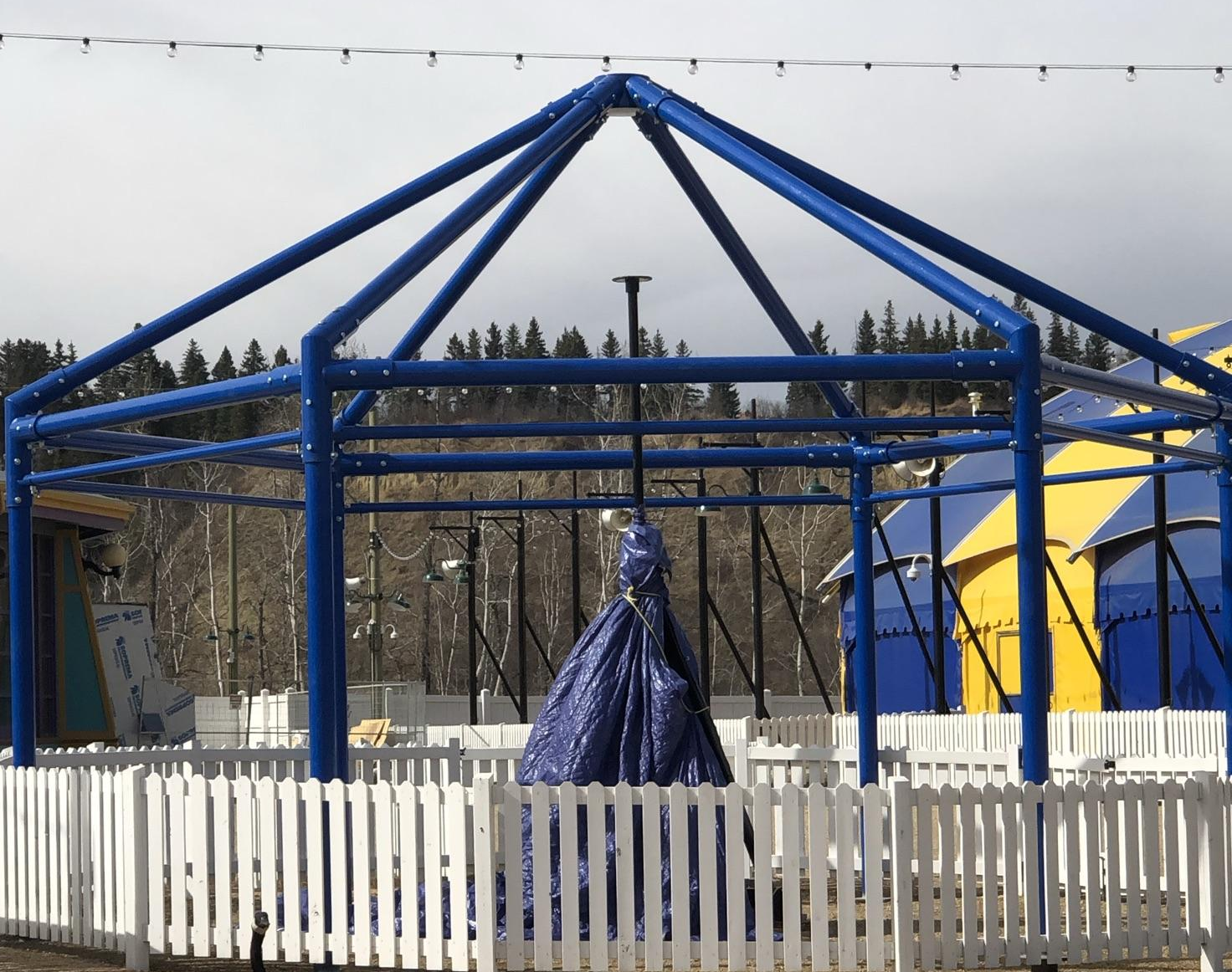

Other Initiatives:
- We are developing a larger raffle or “Lottery” in collaboration with the park re-opening. The prizes will be a series of early bird draws and a final draw totalling $50,000 value. This would be initiated in July/August.
- Sustaining funds have been established with monthly 50/50 raffles using www.forted5050.com and www.skipthedepot.com. The Foundation is participating in public awareness opportunities where it is safe and possible such as West Edmonton Mall, and farmer’s markets, and then planning to return to be onsite at the park once the park re-opens.
- The Annual Fall for the Fort Online Auction will be held in September again this year. Marketing initiatives are underway to secure the media and other sponsors of the event.
- The train vandalism that occurred in the fall has now been repaired and the insurance claim closed with the Foundation’s insurer.
- The Time Capsule project is underway in preparation for the opening season. See separate report for details.
- Donor Recognition is in progress for the various naming opportunities throughout the enhancement project. A review of the current Partner’s Gate is in progress as it is in need of repair or replacement - see images.

